DEPARTMENT OF COMPUTER SCIENCE AND ENGINEERING
CSA0607 – DESIGN AND ANALYSIS OF ALGORITHMS
CO1 – ASSESSMENT TOOL 1
IT APPLICATION-BASED PROBLEM SOLVING
SCALABILITY AUDIT OF AN E-COMMERCE PLATFORM

Platform: ShopSphere
Student Name: K. Hasitha Sai Sree
Registration Number: 192371065

1. Objective
The objective is to audit the algorithmic scalability of ShopSphere as its product catalogue grows from 100,000 to 1,000,000 products. The analysis identifies dominant operations, derives exact counts where possible, solves recurrences, applies asymptotic notation, and estimates whether each module can finish within the required 10-minute nightly processing window.

2. Problem Assumptions
- Current catalogue size: n = 100,000 products.
- Expected catalogue size: n = 1,000,000 products.
- Server rate given in the question: 10 basic operations per second.
- Nightly processing window: 10 minutes = 600 seconds = 6,000 basic operations at the stated rate.
- M1 compares every product with every later product.
- M2 doubles i each iteration and audits j = 0 through i − 1.
- S2 uses binary search on a sorted index and follows T(n) = T(n/2) + 1, T(1) = 1.
- M4 current: T(n) = 4T(n/2) + n; proposed: T(n) = 2T(n/2) + n.
- M5: T(n) = 2T(n/2) + n log n; report generator: f(n) = 3n² + 10n log n + 50.

3. (a) Understand the Problem
Module | Input size | Dominant basic operation | Expected growth
M1 Duplicate detector | n product records | Compare title and seller for each pair (i, j) | Quadratic: Θ(n²)
M2 API rate limiter | n request-window entries | Audit(Request[j]) in geometrically growing windows | Linear: Θ(n)
M3 S1 sequential search | n catalogue entries | Compare target with each product | Best Θ(1), average/worst Θ(n)
M3 S2 binary search | n sorted index entries | Compare target with middle entry | Θ(log n)
M4 recommendation | n customer–product records | Recursive subproblem work plus linear merge | Current Θ(n²); redesign Θ(n log n)
M5 analytics | n sales records | Recursive split plus n log n sorting work | Θ(n(log n)²)
The report generator is also audited separately in part (f). Its dominant term is 3n², so its growth is Θ(n²).

4. (b) Analyse the Iterative Modules

4.1 M1 — Duplicate-Listing Detector
The outer loop chooses i = 0, 1, …, n − 2. For each i, the inner loop compares product i with all later products.
Comparisons = (n − 1) + (n − 2) + ... + 2 + 1
= 1 + 2 + ... + (n − 1)
= n(n − 1) / 2
For n = 100,000: 100,000 × 99,999 / 2 = 4,999,950,000 comparisons.
For n = 1,000,000: 1,000,000 × 999,999 / 2 = 499,999,500,000 comparisons.
Time complexity: Θ(n²), because the exact comparison count is a quadratic polynomial. Auxiliary space is O(1) if duplicate marks are written directly to existing records; if the implementation stores a separate list of duplicate IDs, that output storage can require O(n) space.

4.2 M2 — API Rate Limiter
The outer-loop values of i are 1, 2, 4, 8, … while i < n. Each iteration performs exactly i Audit operations.
Total = 1 + 2 + 4 + ... + 2^(m−1)
= (2^m − 1) / (2 − 1) = 2^m − 1
The number of iterations is m = ceil(log₂ n), so the exact count is 2^ceil(log₂ n) − 1. Because 2^ceil(log₂ n) is at least n and less than 2n for n > 1, the count is Θ(n), not Θ(n log n). The team member’s claim is incorrect: the inner-loop work is not n on every outer iteration; it is 1, 2, 4, 8, ….
For n = 1,024, m = log₂(1,024) = 10; total = 2¹⁰ − 1 = 1,023 Audit operations.
For n = 1,000,000, ceil(log₂ n) = 20; total = 2²⁰ − 1 = 1,048,575 Audit operations.

5. (c) Solve S2 by Backward Substitution
Given T(n) = T(n/2) + 1 and T(1) = 1, assume n is a power of two for the exact closed form.
T(n) = T(n/2) + 1
= [T(n/4) + 1] + 1 = T(n/4) + 2
= T(n/8) + 3
= ... = T(n/2^k) + k
Stop when n/2^k = 1. Therefore n = 2^k and k = log₂ n.
T(n) = T(1) + log₂ n = 1 + log₂ n
Thus T(n) = Θ(log n). For n = 1,000,000, log₂ n ≈ 19.93, so the comparison estimate is about 20.
Space: iterative binary search uses Θ(1) auxiliary space because it reuses a fixed number of variables. Recursive binary search uses Θ(log n) stack space because the recursion depth is logarithmic.

6. (d) Apply the Master Theorem

6.1 M4 — Current recommendation engine
T(n) = 4T(n/2) + n
a = 4, b = 2, f(n) = n.
n^(log_b a) = n^(log₂ 4) = n²
Since f(n) = n = O(n^(2−1)), f(n) is polynomially smaller than n². Master Theorem Case 1 applies.
T(n) = Θ(n²)
When input size doubles, a quadratic cost grows by approximately 2² = 4 times.

6.2 M4 — Proposed redesign
T(n) = 2T(n/2) + n
a = 2, b = 2, f(n) = n.
n^(log_b a) = n^(log₂ 2) = n
Here f(n) = Θ(n^(log_b a)), so Master Theorem Case 2 applies.
T(n) = Θ(n log n)
When n doubles, the dominant expression changes by approximately 2 × log₂(2n)/log₂(n), which is a little more than 2 and approaches 2 for large n. This is substantially better than the current design’s approximately fourfold increase.

6.3 M5 — Sales analytics engine
T(n) = 2T(n/2) + n log n
a = 2, b = 2, and n^(log_b a) = n. Here f(n) = Θ(n log n), which is not Θ(n) and does not fit the three basic cases in their simplest forms.
Using the extended Master Theorem (Case 2 with f(n) = Θ(n^log_b(a) log^k n), k = 1), T(n) = Θ(n log^(k+1) n) = Θ(n(log n)²).

7. (e) Best, Average, and Worst Search Cases

7.1 S1 — Sequential search
- Best case: target is the first item; 1 comparison.
- Average successful case: assuming each position is equally likely, (1 + 2 + … + n)/n = (n + 1)/2 comparisons.
- Worst case: target is last or absent; n comparisons.
Let p be the probability that the target exists. If it exists, expected comparisons are (n + 1)/2; if it does not exist, all n items are checked. Therefore:
E[C] = p(n + 1)/2 + (1 − p)n
For n = 1,000,000 and p = 0.5:
E[C] = 0.5(1,000,001)/2 + 0.5(1,000,000)
= 250,000.25 + 500,000 = 750,000.25 comparisons

7.2 S2 — Binary search
- Best case: target equals the first middle element; 1 comparison.
- Average case: the target is found after a logarithmic number of halvings; Θ(log n) comparisons.
- Worst case: the search follows the maximum-height path or reports absence; at most floor(log₂ n) + 1 comparisons for the usual iterative implementation.
Binary search requires sorted data; maintaining the sorted index is a separate cost not included in the search comparison count.

8. (f) Prove f(n) = Θ(n²) and f(n) is not O(n)
Given f(n) = 3n² + 10n log₂ n + 50, for n ≥ 1, log₂ n ≤ n.
Lower bound: f(n) = 3n² + 10n log₂ n + 50 ≥ 3n²
Upper bound: f(n) ≤ 3n² + 10n² + 50n² = 63n²
Choose c₁ = 3, c₂ = 63, and n₀ = 1. Then 0 ≤ c₁n² ≤ f(n) ≤ c₂n² for all n ≥ n₀. By the formal definition, f(n) = Θ(n²).
To show f(n) is not O(n), assume a constant c could satisfy f(n) ≤ cn for all sufficiently large n. But f(n)/n ≥ 3n, which grows without bound as n increases. No fixed c can bound this ratio; therefore f(n) is not O(n).

9. (g) Scalability Decision at n = 1,000,000
At 10 operations/second, a 10-minute window can accommodate only 6,000 basic operations.
Module / model | Operation estimate | Estimated time | 10-minute window?
M1: n(n−1)/2 | 499,999,500,000 | about 1,584.40 years | No
M2: 2^ceil(log₂n)−1 | 1,048,575 | about 1.21 days | No
S2: binary search | about 20 comparisons | about 2 seconds | Yes
M4 current: n² proxy | about 1,000,000,000,000 | about 3,168.81 years | No
M4 redesign: n log₂n proxy | about 19,931,569 | about 23.07 days | No at 10 ops/s
M5: n(log₂n)² proxy | about 397,267,426 | about 1.26 years | No
Important estimation note: M1, M2 and S2 use the counts derived from the specified algorithms. For M4 and M5, the question gives recurrences but not base-case costs or the exact mapping between recurrence work and the phrase “basic operation.” Their totals are therefore explicitly labelled asymptotic proxies, not exact counts or measured execution times. They are useful for comparing growth, but should not be treated as benchmark results.

Recommendations
- M1: redesign the pairwise duplicate scan. Use a hash set keyed by normalized (title, seller), or sort by the composite key and scan adjacent entries. Expected processing can be reduced to O(n) with hashing or O(n log n) with sorting.
- M2: the doubling-window loop is Θ(n), but its count still exceeds the strict 10-minute budget at the stated rate. Process only necessary request buckets, use aggregated counters, and benchmark actual operation costs.
- S2: keep the sorted index and binary search for lookup; ensure index maintenance cost is considered separately.
- M4: remove replicated recursive partitions as proposed. The change improves Θ(n²) to Θ(n log n), but the given 10 ops/second model still predicts more than 10 minutes at one million records. Benchmark and consider parallelism, caching, or incremental computation.
- M5: investigate incremental analytics, pre-aggregation, and avoiding repeated sorting at every recursion level. Measure actual run time before production decisions.

10. Program Execution and Verification
Language: Java. The program uses only the standard library and can be compiled with JDK 21 or later.
javac ShopSphereScalabilityAudit.java
java ShopSphereScalabilityAudit
The attached output file is the captured console output from a successful local compilation and execution. The code prints formula checks and model-based time estimates. It does not claim that the estimates are measurements from a live ShopSphere system.
Source code screenshot:
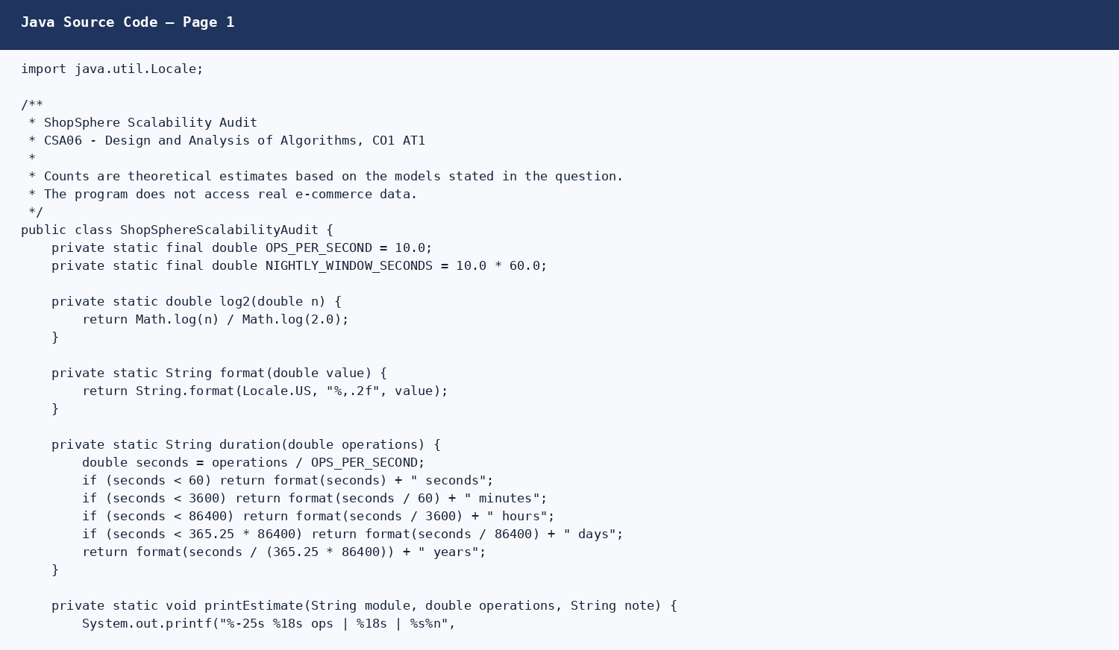
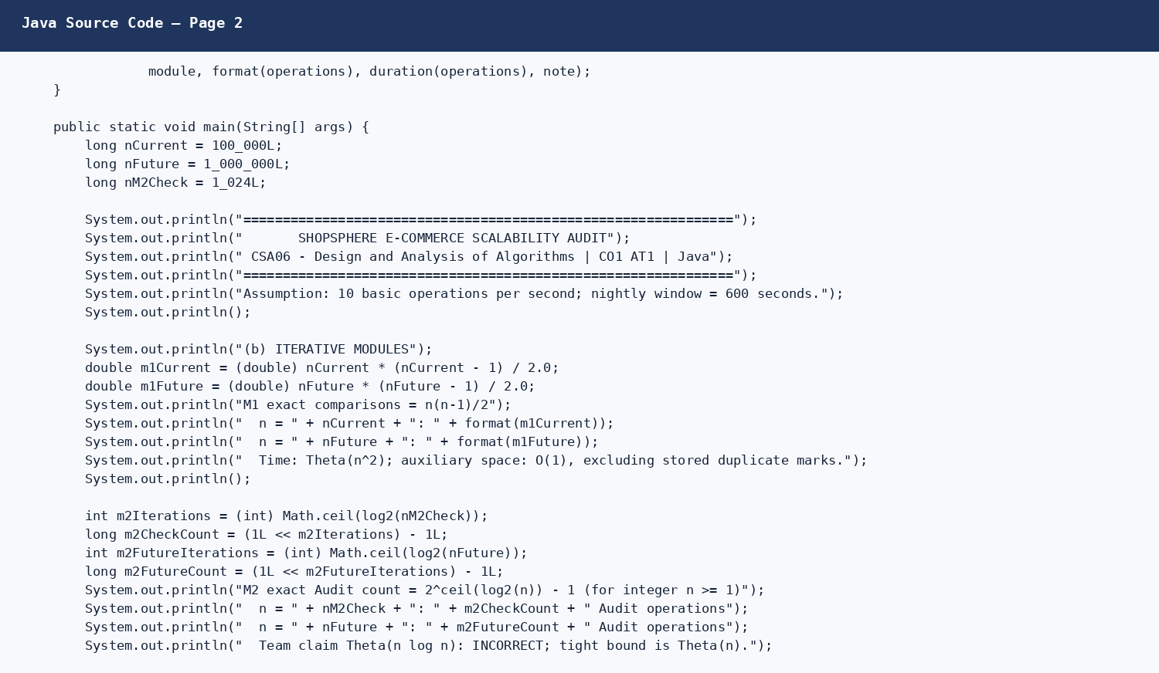
Program output screenshot:
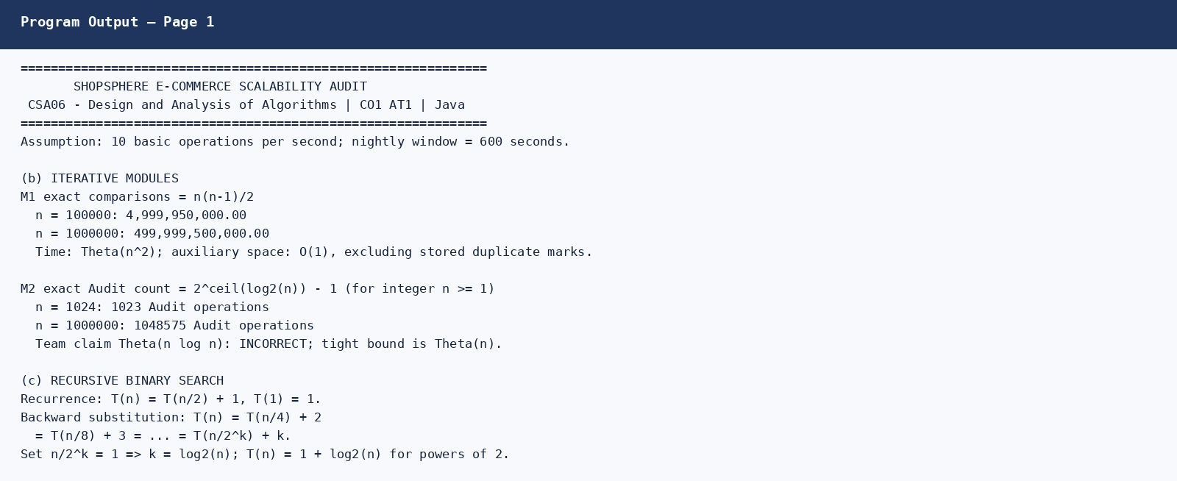
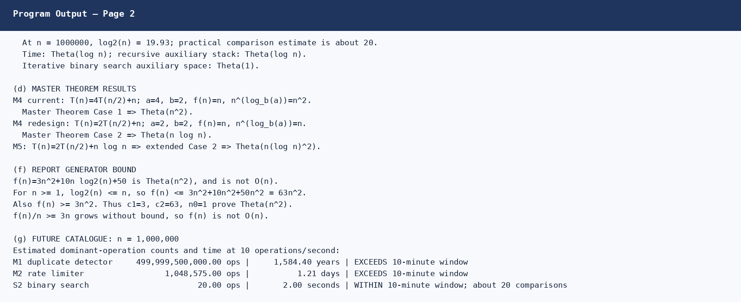
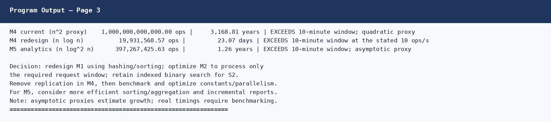

11. Conclusion
The audit shows that asymptotic growth has a major effect on the one-million-product catalogue. M1 is the most urgent redesign because its pairwise comparisons grow quadratically. M2 is linear, but its operation count still exceeds the given nightly window at the stated server rate. Binary search S2 is the most scalable lookup option among the two search versions. Removing replication improves M4 from quadratic to n log n growth, while M5 has n log-squared-n growth. All estimated durations should be validated with real benchmarks and measured operation costs.

12. Submission Checklist
- Replace the student name and registration number placeholders.
- Check that the Java file compiles and runs on your system.
- Review the report and be ready to explain the derivations during viva voce.
- Upload the CO1_AT1 folder to a GitHub repository with the README at repository root.
- Submit only the GitHub repository URL through Google Classroom, as instructed.

